1. Using configuration migration tool create schema with all the related entities and attributes.



Above schema file contains products and kb articles information.

1. Using above schema file export data from target system. Data exported in zip file.

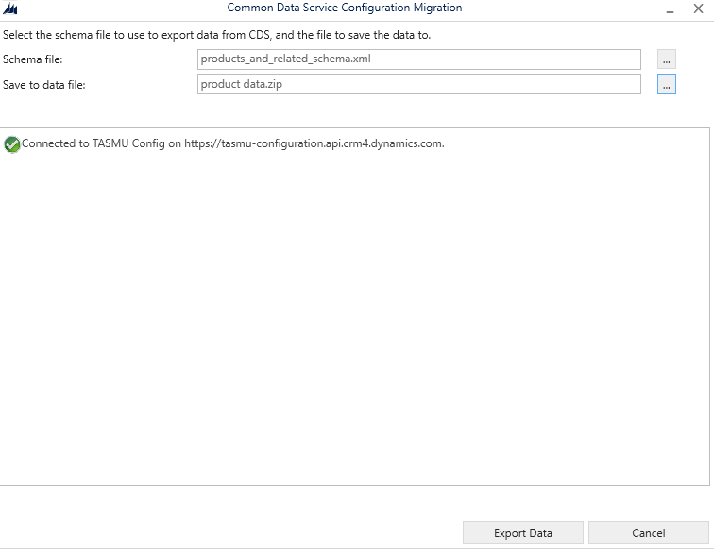

1. Exported zip file contains products data and products related data and KB Articles data.
2. Zip file contains only activate products data.
3. Import data using zip file in the target environment.

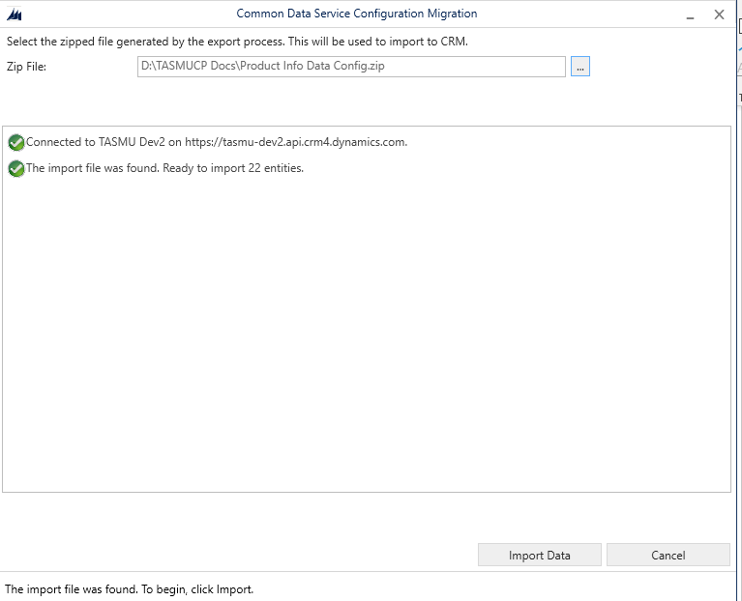

1. We have limitations on product catalogue migration.
2. We can add product properties only on draft and revise products.
3. Bundle association happen only on Draft products.
4. After successfully importing the product catalogue data go to target environment and revise the products using revise button on product.



1. Again Import the same data file to the target environment. Now product properties also added .
2. If any “Bundle & Associations” require then clone the product and associate manually and delete existing product bundle. Product clone happen using clone button in product record.



1. Tag and Sector sections are N:N relation to product entity. If any tags and sectors related to the product we need to associate manually.

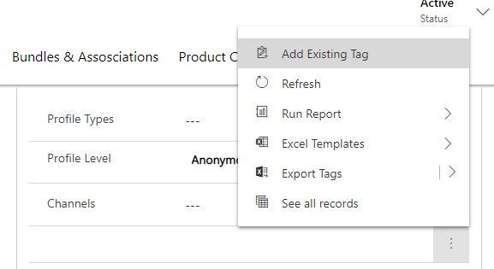

Note: Please refer below SharePoint location for Product schema files.

<https://microsofteur.sharepoint.com/:f:/t/TASMU-BizAppsTeam/EhIPJ_uXvWNKjlgNbjCDVCwBKJq0pXePlXuVewYJes_gOA?e=uXwcqx>